Process Framework:
- Generic structure defines the fundamental activities required in every software development projects.
- It’s not a specific process model like Waterfall or Agile. It’s a framework.
Activities:
- Communication
- Planning
- Modeling: Analysis of requirements, Design
- Construction: Code, Test
- Deployment
- Role: PM
Who will engage:
- Communication: BA, PO (Product Owner), PM (Product Manager)
- Planning: Project Manager
- Modeling: System Analysis
- Construction: Developer, Tester
- Deployment: DevOps

Umbrella Activities:
- Hoạt động luôn chạy song song với những hoạt động của Process Framework để kiểm soát chất lượng.
- Activities:
Software project tracking and control
Risk Management
Software quality assurance
Technical Reviews
Measurement
Software configuration management
Reusable management
Work product preparation and production

Who will engage:
- Non-technical

Process Assessment:
- CMMI method has 5 steps:
+ Initiating
+ Diagnosing
+ Establishing
+ Acting and Learning
- CBA IPI (CMM-Based Appraisal for Internal Process Improvement)
+ assessing the relative maturity of a software organization
+ use SEI CMM
- Evaluating organizational process maturity

- ISO 9001:200 for Software
+ generic standard to improve overall quality.
Task Set:
- The actual work is to be done in the Framework Activities.
Ex: Communication in Framework Activities, a task needs to be done is to collect relevant information, …
Process Pattern:
- It describes a process-related problem that encountered during software development work,
- identifying the environment in which the problem encountered
- suggests solutions to the problem.
(khuôn mẫu để giải quyết vấn đề thường gặp trong swe)

Other Process Models:
- Component-based development: reuse component
- Formal methods: emphasize the mathematical specification
- AOSD: provides a process and methodological approach
- Unified Process: use-case driven, architecture-centric, iterative and incremental

Process Models:
Software process:
- is a structured set of activities required to develop a system
- Specification
- Design and implementation
- Validation
- Evolution
Software process model: mô hình để mô tả cách bạn làm
Ex: waterfall, agile, incremental, spiral

Process | Model
Làm tuần tự | Waterfall
Làm lặp | Agile
Làm theo increment | Incremental
Làm theo risk | Spiral

Planing-driven and Agile Processes

Plan-driven processes
- are processes where all of the activities are planned in advanced and the progress is measured against the plan.

Agile processes
- Planning is incremental (step by step) and easier to change
- It is a family of software development methodologies allowing greater changes in design and in short iterations.
- Focus on human and team aspect (labor intensive)
Prescriptive Models:
- Là 1 nhóm các mô hình
- They strive for structure and order including: Waterfall, Spiral
- Waterfall
- Plan-driven model
- Separate and distinct phases (each phases: Requiremnet, Design, Implement, Testing, Deployment are clearly separated)
- Document intensive
- Progress measured through documentation
- Gantt chart (keep track timeline)
- Lockstep approach (làm tuần tự, không quay lại)
- Little chance for change

- Limitation:
+ The difficulty of accommodating changes after the process is underway.
- When to use:
+ The requirements are well-understood and changes will be fairly limited during the design process.
- Risk:
+ Late detect, at the last stage
- Scale (quy mô):
+ Government/Military project

- It is Big-Bag delivery (giao khách hang 1 lần duy nhất khi hoàn thành)

- Incremental Models
- Requirements are divided into multiple standalone modules of the software development cycle.
- Each module will go through the cycle: requirement, design, implementation, testing phases.
- Enabling the team to release usable versions of the application early
- Focus on delivering a full module in each increment.
Ex: 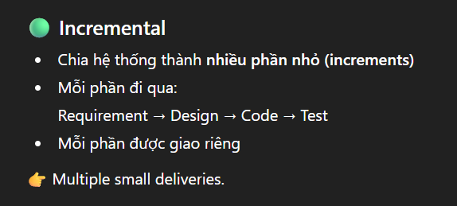

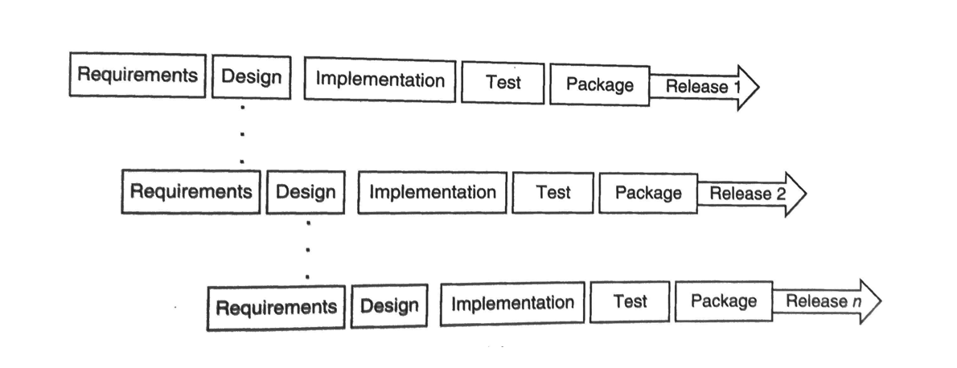
- Limitation:
+ Total cost is higher than waterfall
+ Clear and complete definition of whole system

- When to use:
+ Lower initial delivery cost (không cần xây toàn bộ system ban đầu, khách có thể dùng 1 function nhỏ trước)
+ Flexibility: accommodate changing requirements and allow adjustments
+ Risky projects, new technologies

- Risk:
+ Manage by divided into smaller modules

Advantages of this scenario
- Early Value Delivery: Users can start using the core functionalities of the application early, providing immediate value.
- User Feedback: Incremental releases allow continuous user feedback, ensuring that the application evolves to meet user needs effectively.
- Risk Management: Smaller, manageable increments help identify and mitigate risks early in the development process.
- Flexibility: The model accommodates changing requirements and allows for adjustments based on user feedback and market demands.

- Spiral Model
- Represented as spiral rather than as sequence of activities with backtracking
- Focus on risk management
Instead of asking:
“What feature do we build next?”
It asks:
“What is the biggest risk that could cause this project to fail?”

- Each iteration mainly focuses on how to reduce the risk of the system
- Including:
+ Planning
+ Risk Analysis
+ Engineering (design & code)
+ Evaluation (feedback)

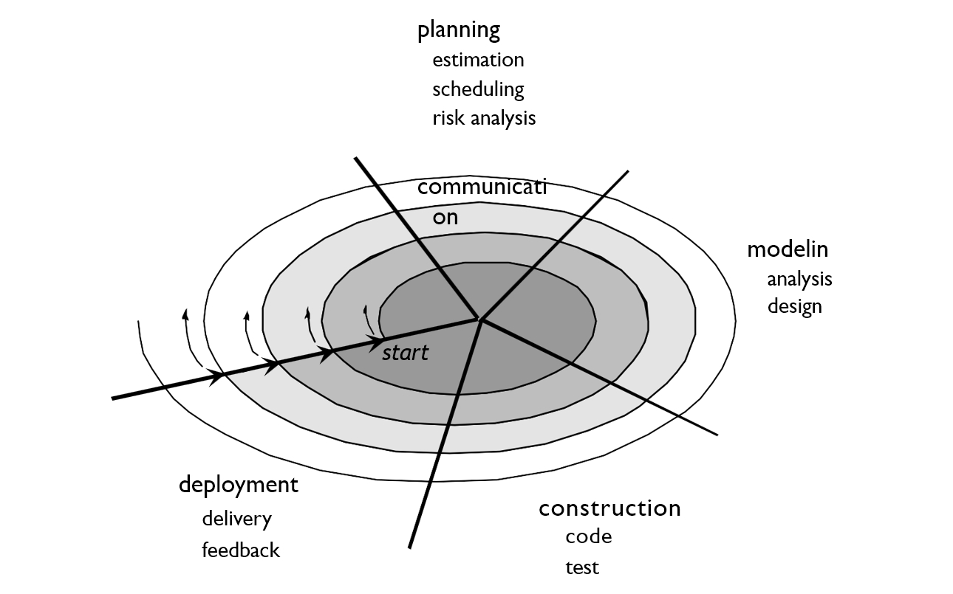

- Limitation:
+ The difficulty of accommodating changes after the process is underway.
- When to use:
+ The requirements are well-understood, and changes will be fairly limited during the design process.
+ A risky project, extreme uncertainty of successf cul
- Scale (quy mô):
+ Big project, High risk, Unclear requirements

Advantages of this scenario
- Risk Management: The ___ Spiral_______ model's iterative risk analysis helps manage the complex integration of third-party services and ensures scalability and security are addressed.
- User Feedback: Continuous stakeholder engagement allows for frequent feedback, ensuring the platform meets user needs and expectations.
- Flexibility: The iterative nature of the __Spiral_______ model accommodates changing requirements and evolving business needs, providing flexibility in development.

- RUP (Rational Unified Process)
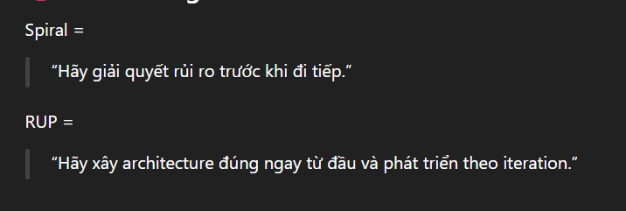

It has a certain phase:
+ Inception: initialize business case, risk assessment, planning => to see is it possible to do.
+ Elaboration: build software architecture, detail analysis
+ Construction: coding & implementation
+ Transition: Deliver software increment, General user feedback

Inception = “Should we do it?”
Elaboration = “How should we build it safely?”
Construction = “Build it.”
Transition = “Deliver it.”

- Focus on Architecture centric.
- Each phases has 6 discipline: requirements, analysis, modeling, design & code, testing, deployment
- But different intensives
Ex:
Inception: more requirements but less implementation
Elaboration: more Architecture & design but less coding
Construction: mostly coding
Transition: Deployment & testing

- The V-Model
- A transition of Waterfall
- Left side is Development and Right side is Testing
- 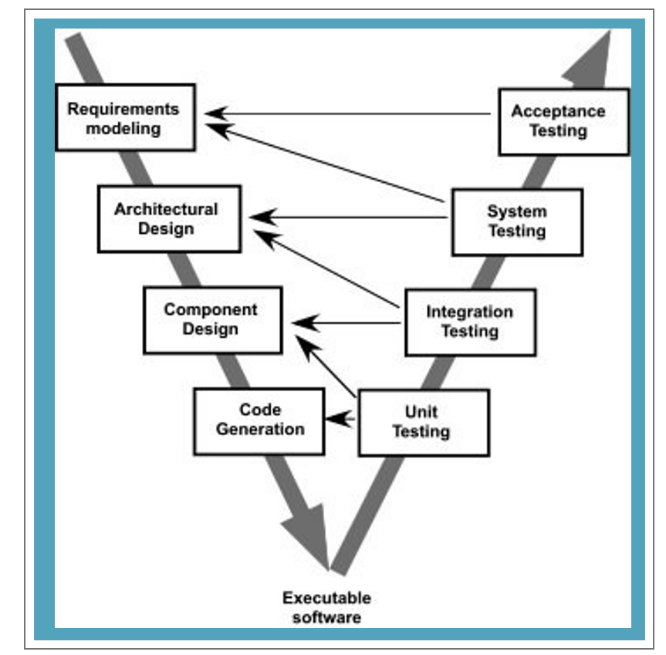

Agile processes:
Characteristic:
- Short release and iteration:
- Increment design (không thiết kế hoàn chỉnh từ đầu)
- User involvement: asking for user feedback constantly
- Minimal document
- Adaptive: Changeable document & environment
Principles:
- Satisfy the customer through (early and continuous delivery)
- Welcome changing requirements
- Delivery working software frequently
- Business people and developers must work together daily throughout the project
- Build around a motivated individual (Trust each other)
- Face-to-face communication
- Measuring progress is the working of the software
- Sustainable development (maintain the constant pace of building)
- Technical excellence and good model design
- Regular reflection and improvement

- Extreme Programming (XP)
- One of the first methods in Agile Process
- Small team working in a small room => encourage more communication
- Minimal documentation => only necessary documentation

Core value:
- Communication between team members and customers
- Simplicity in design and code
- Feedback at many different levels
- Courage (dám refactor, dám xóa code xấu, …)

Key Practices of XP:
- Planning:
Quick determination of features for next release
- Short release:
release frequently to get feedback
- Metaphor:
use simple images to describe the system for everyone to understand
- TDD (Test-driven development):
Write test case first, then code.
+ Write test case
+ Test fail
+ Write code to pass the test
+ Refactor
- Simple Design
- Refactoring:
- Pair Programming:
Code is always reviewed by a second person
- Collective ownership:
Establish ownership of the whole team
The code does not belong to anyone
- Continuous integration:
Integrate code to the project continuously to avoid tích tụ lỗi
- Sustainable pace:
Avoid burn out causing bug
- On site customer
- Coding standard

When to use XP?
- Expect the functionality to change every few months
- Work with customers who aren’t sure what they want
- Minimize project risk (by Pair programming, TDD)
- Small team
- Work closely with customers

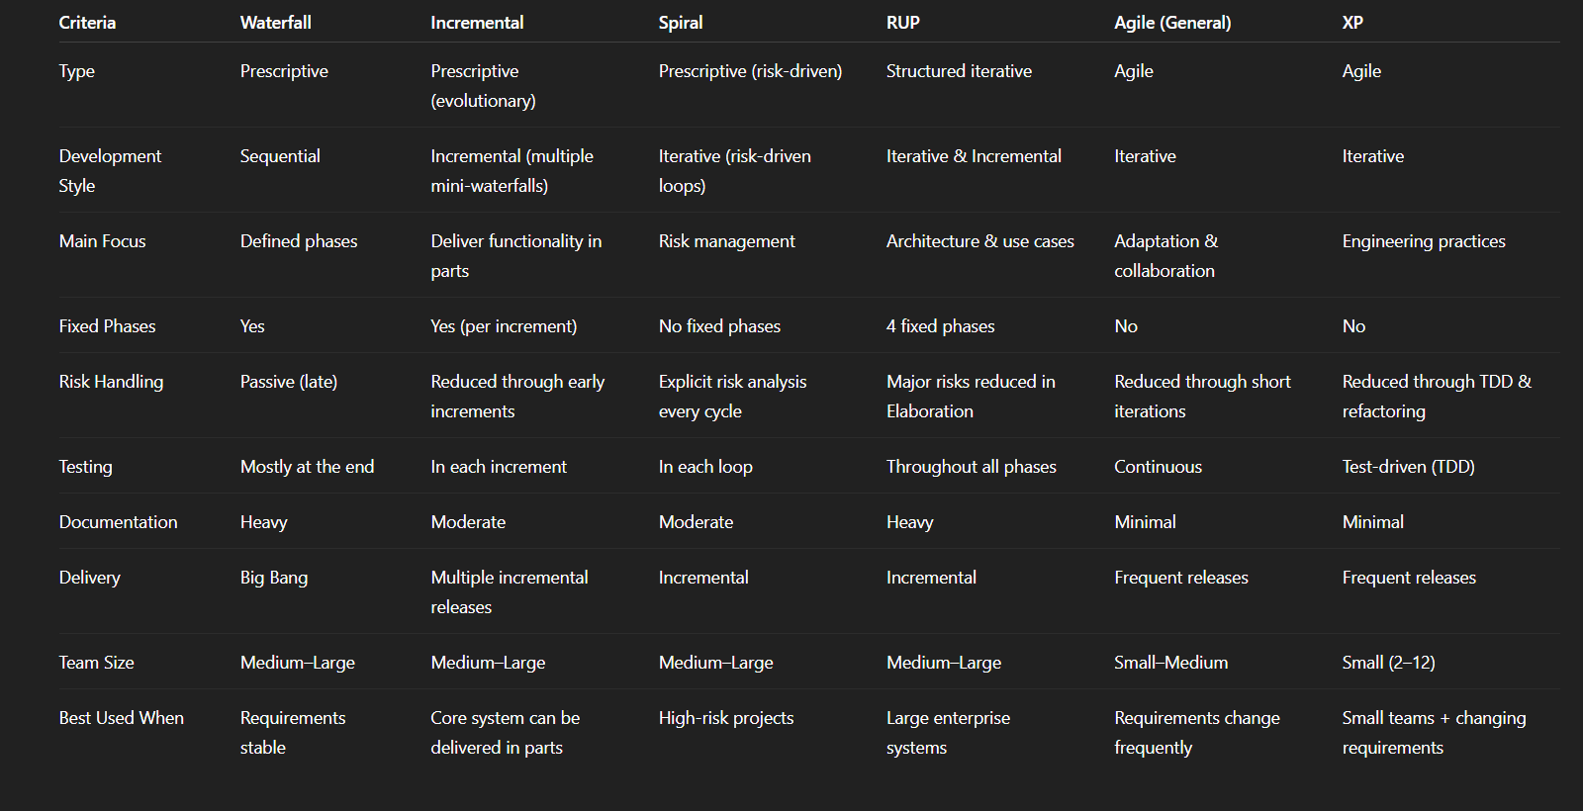

SCRUM

- Iterative
- Incremental
- Sprints
- reprioritization of features
- Involving customers collaboration to get feedback
Roles:
- Product Owner: Manage Backlog (write requirements, user stories)
- Scrum Master: Takes care of the process of Agile model
- Scrum Team: Developers and Testers
Sprint: 1-4 weeks

Activities:
- Sprint planning: select backlog items and define sprint goal
- Daily Scrum: Meeting 15 minutes every day to report.
- Sprint Review: gather feedbacks and update backlog

